Criterion B: Design

*Design overview:*

The program will have two main forms: entertainment and theory. The first window that opens, when the game starts, will consist of the title, some description and two choices: to play or to learn. (*Figure 1*) I have chosen to use Tiffany’s color (82, 183, 189 in RGB form) and purple color (187, 41, 187 in RGB form) because they are client’s favorite.

Classes: title page; page with theory that has a title of the level and several buttons with the different courses of English grammar, as level and course are chosen, new updated page that contains the information will open; main page of two games and the dialogue; “Fill In the Blank Game” page that has several questions and counts the scores; “Word Search Puzzle” page with several questions; help page that explains the purpose of the application, how to play the games and the sources of the information taken.

Theory pages will have pictures, words, some diagrams and so on, in order to make it easier to the client to learn the English language.

Entertainment page will consist of score, questions with possible answers and pictures.

**Main Page Design**

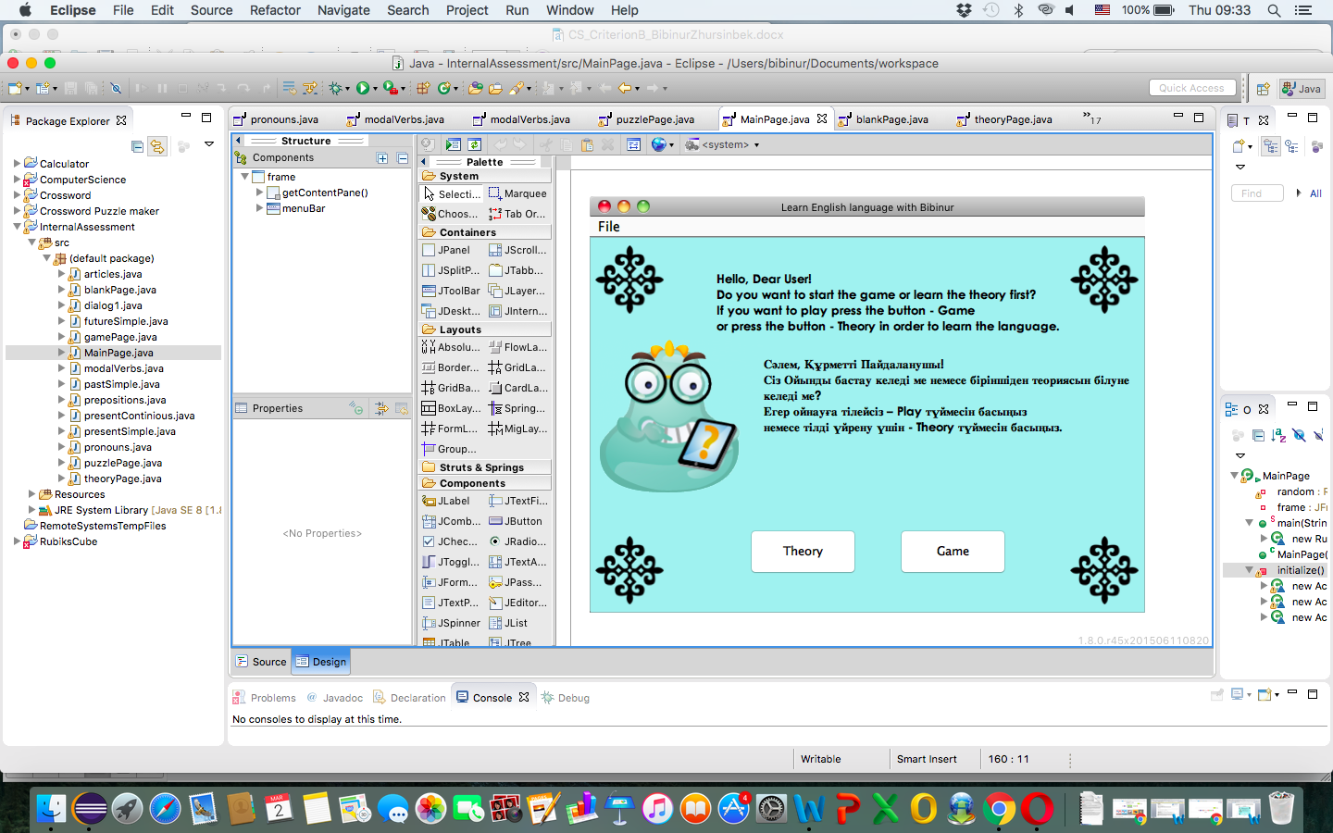

*(Figure 1)*

**Theory Page Design**

Based on the client’s choice, two different main windows will open. So, if the client decides to press the button “Theory”, then this window will open. There are 3 main levels - “Бастауыш” (Beginner), “Ілгерi” (Advanced), “Сарапшы” (Proficient). Also, there are several courses based on the level. *(Figure 2)*

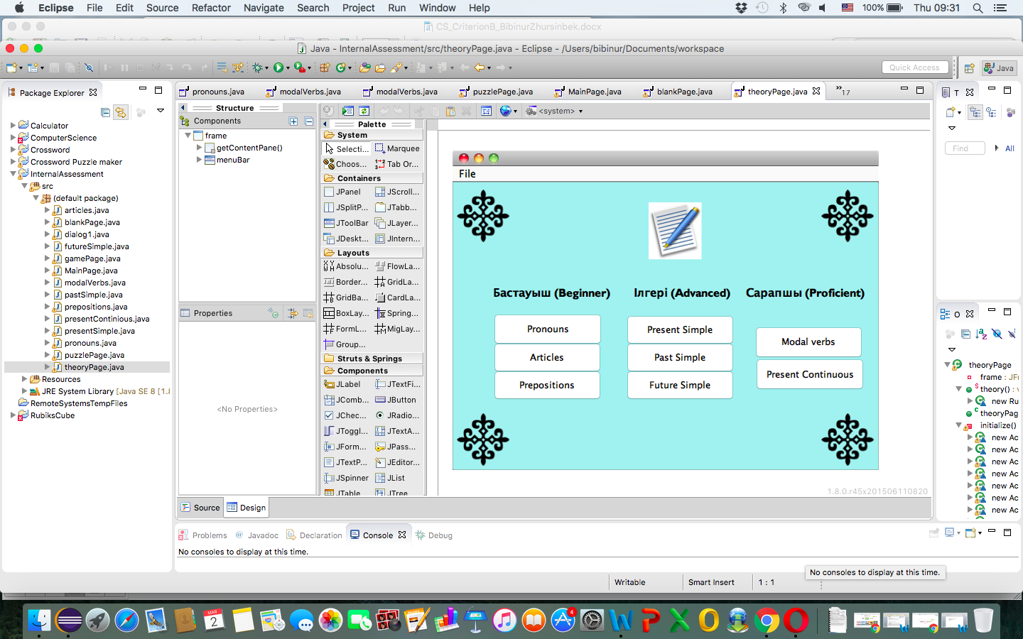

*(Figure 2)*

The name of the courses is written of the buttons. As the client pressed the specific button, the information of the course will open. (*Figure 3*)

For example, the Figure 3 represents the page off the “Pronouns” course of the level “Бастауыш” (Beginner).

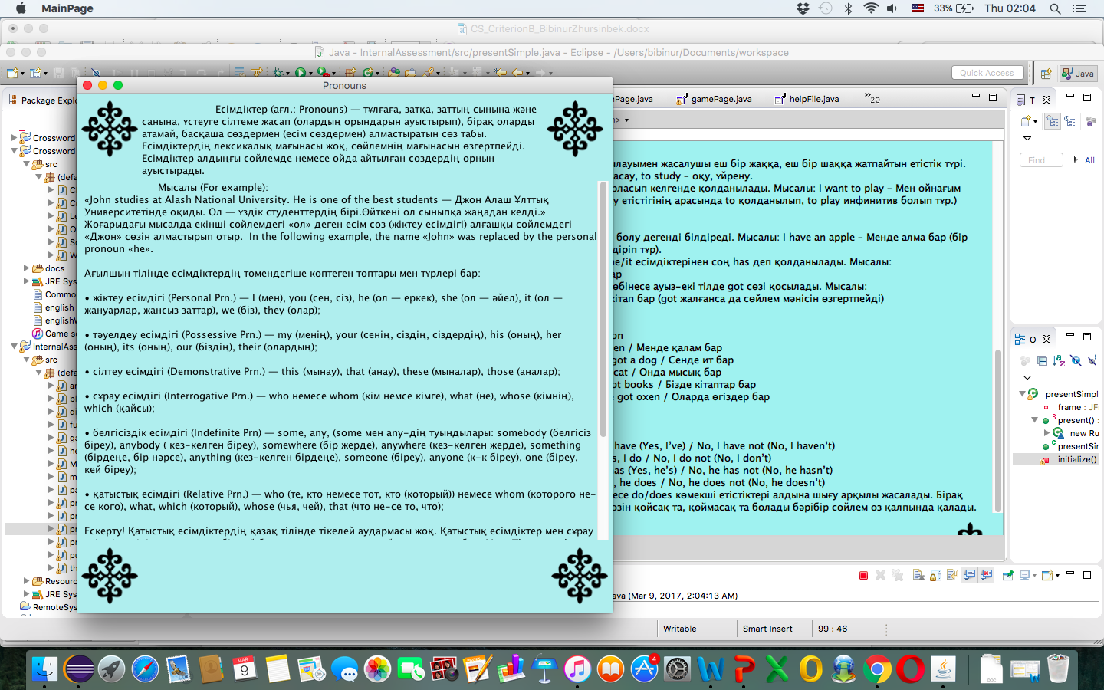

*(Figure 3)*

**Game Page Design**

After the client pressed the button Game, the new window will be opened where she will have an opportunity to choose between two games: words search puzzle and filling the blank. Also, there is the “Dialogue” that opens new page with the example of the possible phrases on the “At the Restaurant” topic. The dialogue can be listened. *(Figure 4)*

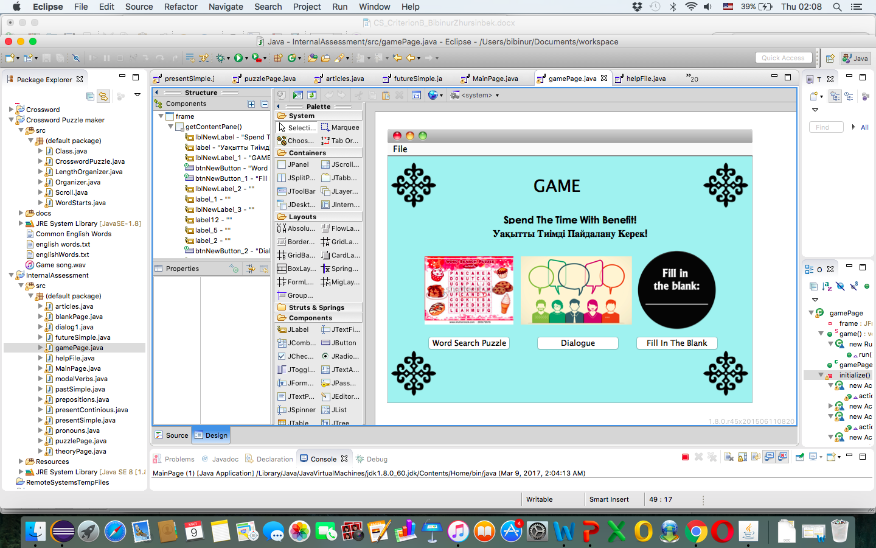

*(Figure 4)*

When the “Fill In The Blank” game is chosen, this window will open *(Figure 5).* There will be about 8 questions. It will add the one point if the answer is right and take one point if the answer is wrong. There is no limit in the errors. At the end of the game, as the button “Finish” is pressed, it will display the number of scores, which can be positive and negative. The aim of the game is to help the individual make the analysis according to the information whether she has a progress or regress.

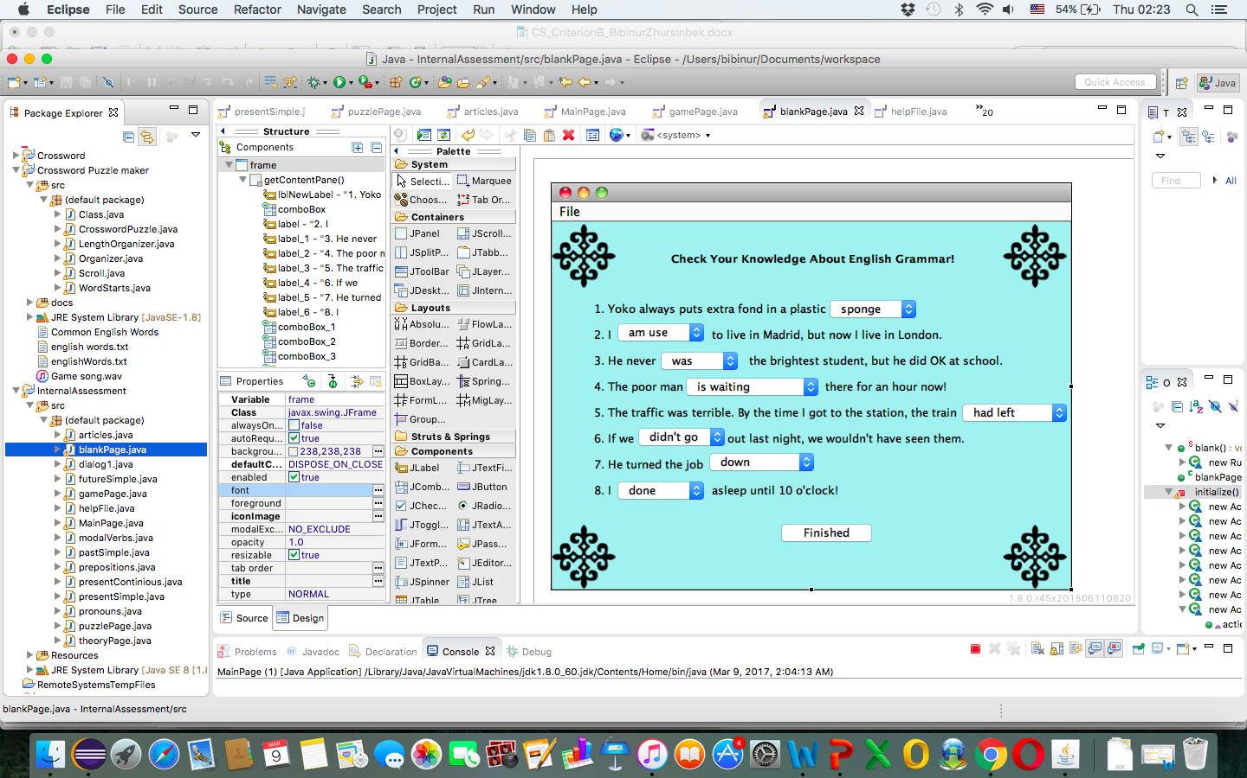

*(Figure 5)*

Second game’s name is “Word Search Puzzle” *(Figure 6).* The purpose of the game is to increase the vocabulary based on “Animal” topic. There will be given the statement and the user has to find the answer. The answer can be found vertically, horizontally, from right to left or from left to right. The “Submit” button will check if the answer is right or not.

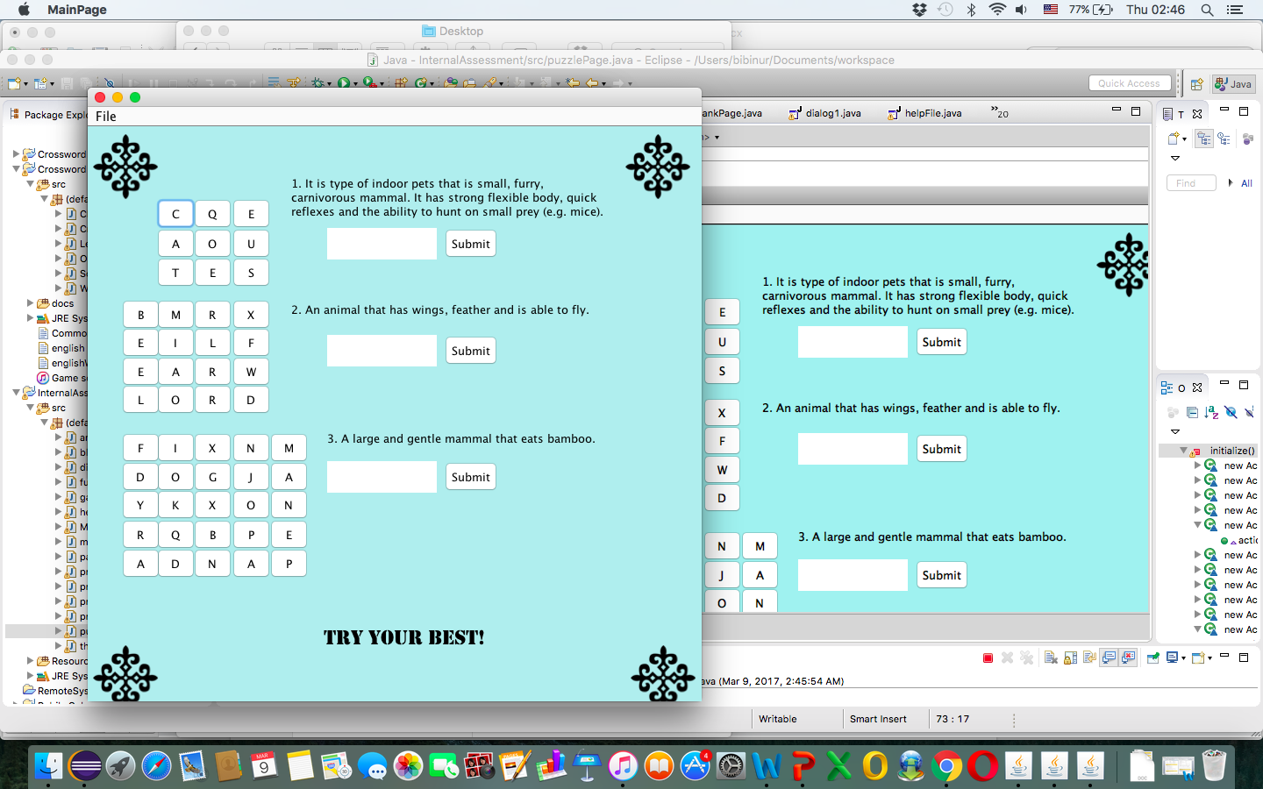

*(Figure 6)*

The next option in the Game page is Dialogue. This information allows the user to be prepared on the “At the restaurant “ topic. Moreover, the client can listen to the dialogue, in order to know how to spell some particular words. She also can stop the dialogue and listen it from the beginning (Figure 7).

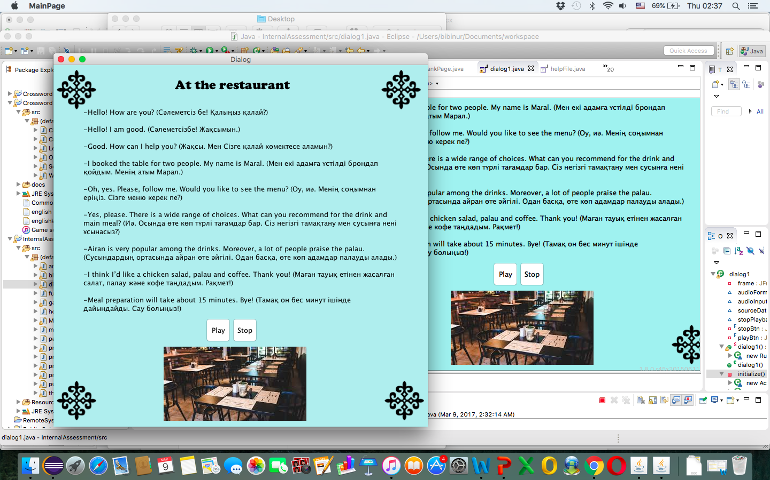

*(Figure 7)*

The Help page shortly explains the purpose of the application. Also, it consist of information on how to play the games and the resources of the taken information and used pictures. (Figure 8)

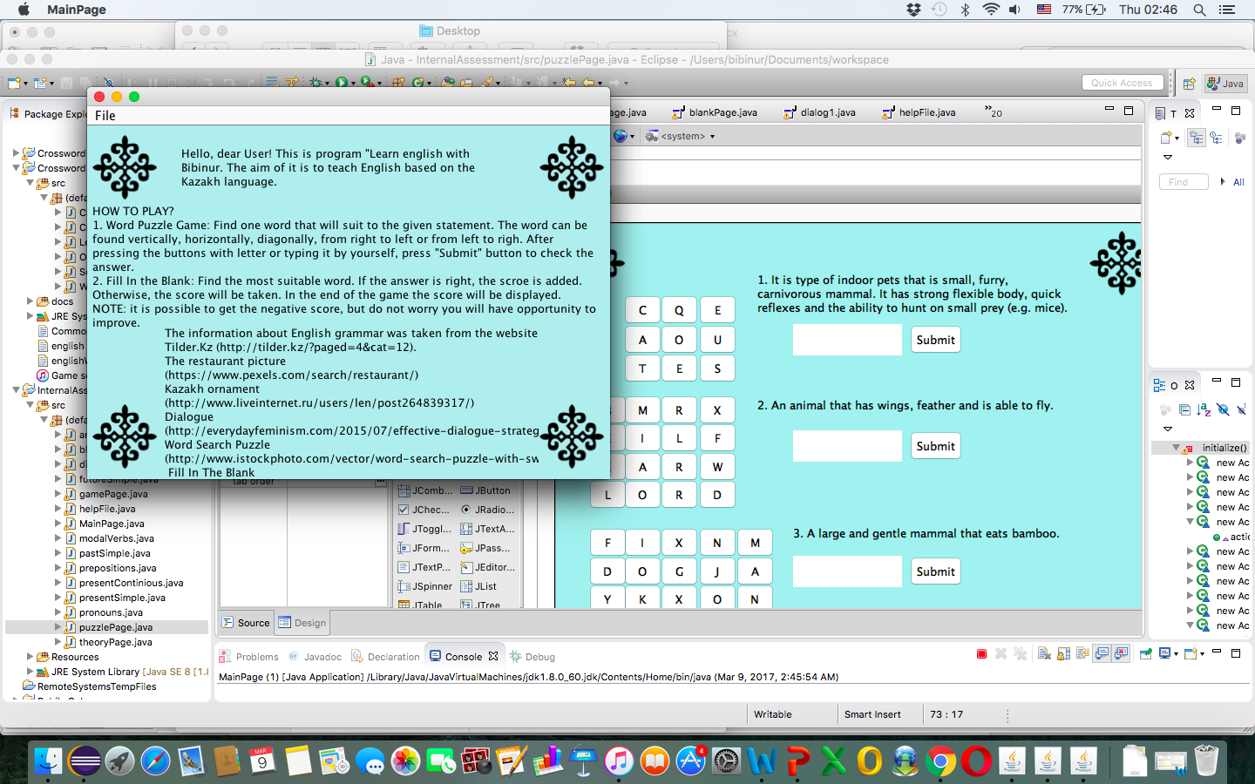

*(Figure 8)*

**Test Plan**

These tests need to be carried out to ensure that the program fulfills the success criteria and user requirements.

|  |  |
| --- | --- |
| **Action to test** | **Method of testing/ Expected result** |
| Correct windows are opened when the button is pressed | The program contains a lot of different windows: Main Page, Education Page, which has different courses, Entertainment Page, which has different games. Thus, there can be a problem with connecting the button and opening right window. In order to check the correctness of the window, all the buttons will be pressed and checked. |
| The number of errors are counted correct | Play several times and count the errors by myself, in order to check if it displays right or wrong score number. |
| Menu bar works correctly: the application can be closed, right windows are opened (going from Game page to Theory page and vise versa); help file | In order to check the correctness of the connection of the pages, all the menu items will be pressed and checked. |
| The audio plays as the button “Play” pressed and stops as “Stop” button is pressed | The quality (the sound) of the audio will be checked. In order to check the functionality of the buttons, they will be pressed and checked. |
| The user is able to press all buttons with letters and letters are all displayed in the right text area. The submit button works correctly, as it displays the right message dialog. (“Word Search Game”) | All the buttons will be pressed to check their functionality. In order to check the message dialog, wrong and right answers will be typed in the text area and button “Submit” will be pressed. |

**Flowchart**

**Main Flowchart**

The main flowchart consists of the decision between Theory page and Game page. As the program starts, Main Page opens (*Figure 1*), the client has to decide whether to open Game Page or not.

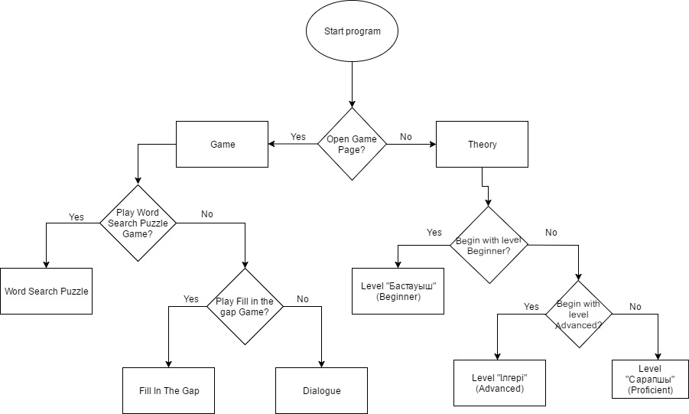

**Level’s Flowchart**

This flowchart represents the further steps, when the client pressed the button Theory (*Figure 2*). When the client decides to start the Level Beginner, a number of courses will be opened. The user will be allowed to move from one course to another.

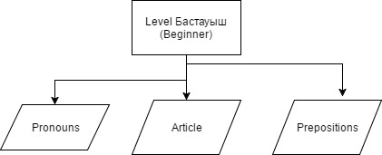

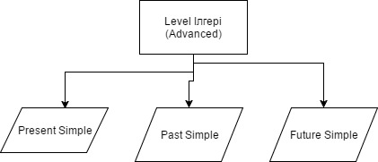

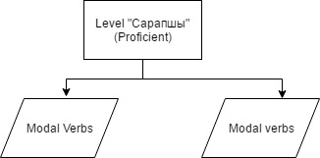

According to the flowchart, the Level Page will look like this but there will be different information according to the level. (*Figure 3*)

**Game Word Search Puzzle’s Flowchart**

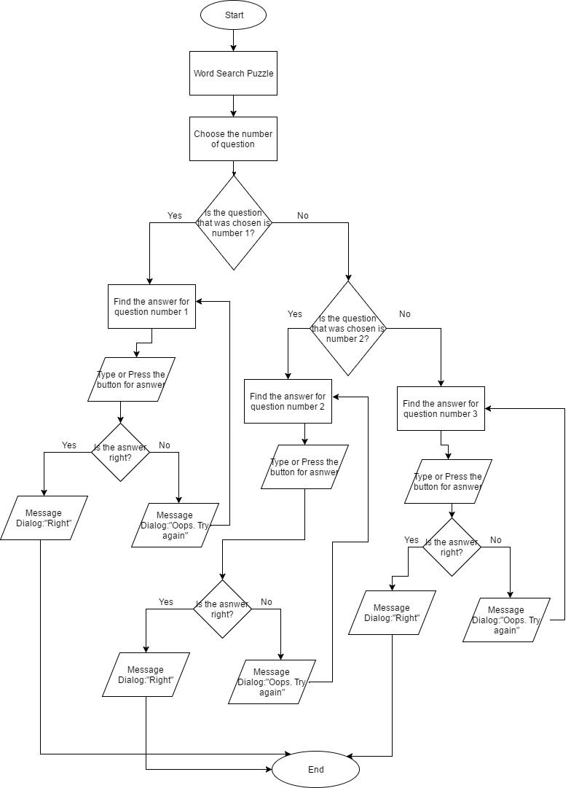

**Game Fill the blank Flowchart**

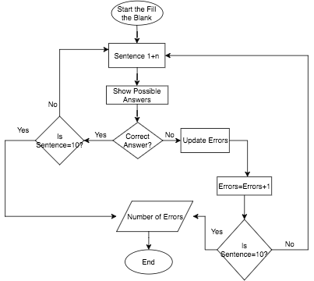

**Pseudo code**

**Choose Theory/ Game**

*Boolean THEORY // parameter variable parameter clicked*

*if THEORY=true*

*then theory window opens*

*else if THEORY=false*

*then game window opens*

*end if*

**Start (Theory)**

*boolean isBeginner;*

*boolean isAdvanced;*

*boolean isProficient;*

*choose level*

*if isBeginner=true*

*then open BeginnerLevel*

*else*

*if isProficient=true*

*then open ProficientLevel*

*else*

*if isAdvanced=true*

*then open AdvancedLevel*

*else*

*stay on the Main window*

*end if*

*end if*

*end if*

**Start (Game)**

*boolean SentenceCompletion;*

*boolean Hangman;*

*choose game*

*if SentenceCompletion=true*

*then open SentenceCompletionGame*

*else*

*if Hangman=true*

*then open HangmanGame*

*else*

*stay on the Game window*

*end if*

*end if*